**Budda’s Birthday**

When it is held: 9th day of lunar April.

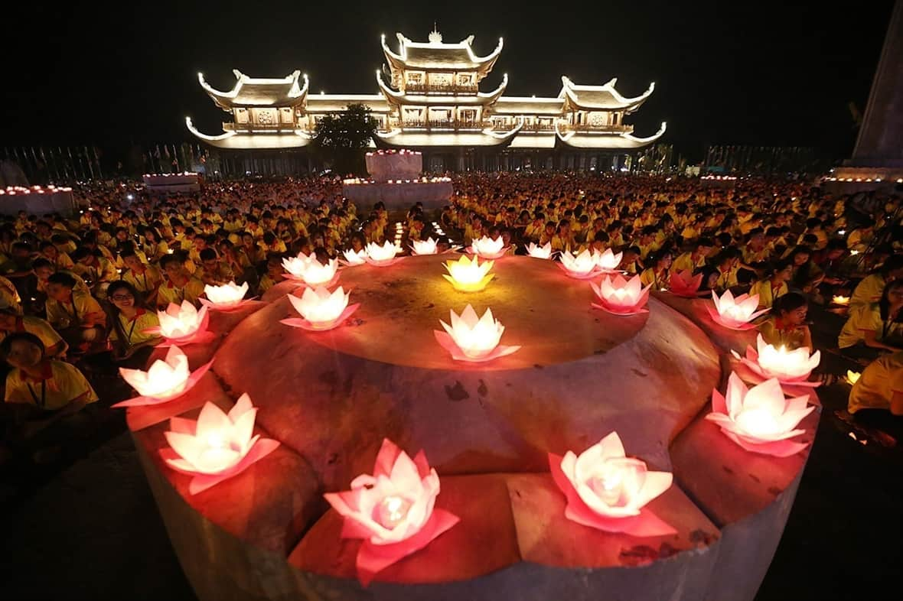- Recommended places: Quan Su Pagoda, 73 Quan Su street, Tran Hung Dao ward, Hoan Kiem district, Hanoi.

- With more than 50% of the population following Buddhist practices, Buddha’s Birthday becomes a really important event to Vietnamese people. It is their chance to commemorate the birth, enlightenment, and the death of Buddha. In Vietnam, it is not just a religious festival but also a national festival. Before the festival, hundreds of monks and thousands of people will gather in big pagodas chosen to be the holding place. These pagodas will be cleaned and decorated with Buddha’s statue in the middle of a pink lotus. Around them, there are also many colorful lanterns, different kinds of flowers, and small lotus flowers.- Buddhist followers will gather in the early morning of the 15th day to prepare for the festival. Buddha’s Birthday has 2 main parts including the ceremony and entertaining activities. For thousands of years, sacred rituals like offering incense and flowers to celebrate the birthday of Buddha and pray for peace still remain. Also on this day, people will actively participate in charity activities like helping the unlucky, mental retarded and the elderly. Visiting the pagodas during the festival, you will have a chance to enjoy delicious Vietnamese vegetarian dishes.